1. **Introduction**

During the Enterprise Web Software Development course, we will form a team of up to six members to do research and work together with the overall goal of completing the Coursework group of this subject. This Coursework group requires that we will build together a web-based secure role-based system for eTutoring in a large university. For members who will play the roles of the database designer, programmer, web designer, and tester, but these roles will not be fixed, members will take turns to participate in other roles so that they can experience and learn. more knowledge. Together, we will learn how to effectively apply Agile Scrum throughout the project.

1. **Coursework planning and analysis**
   1. **The role of each member**

|  |  |  |
| --- | --- | --- |
| **Role** | **Name** | **work** |
| Designer | Nguyễn Minh Tâm | Design user-interface |
| Front-end | Vũ Trần Trung hiếu | Develop user-interface base on the design |
| Back-end developer | Trần Ngọc Huy | Develop function base on requirement |
| Database design | Lê Tiến Dũng | Develop database |
| Tester | Lê Tấn Nguyện | Test function with many cases that can happen |

* 1. **Tools and Technologies**

During the course of this project, the team agreed to use the C # language along with ASP.NET MVC technology for web development. Also, database storage will be performed by Microsoft SQL Server. Below is a list of the tools the group will use:

* Visual Studio 2019
* Microsoft SQL Server 2007
* Microsoft Office word
* Microsoft Office Excel
  1. **Project objectives**

|  |  |
| --- | --- |
| **Objectives** | **description** |
| All student must have a personal tutor | Each student will have a personal tutor to manage their study |
| Any authorized member of staff can allocate or reallocate personal tutors to students. | Personal tutor for students can be allocated or reallocated by an authorized member of staff |
| The student and the personal tutors will get notification emails when allocate or reallocate happens | The system will notify students and the personal tutors when the allocate or reallocate happen |
| Bulk allocation of students to their personal tutor (eg 10 at a time) needs to be implemented. | Member of staff can Bulk allocation of students (eg 10 at a time) to the personal tutor |
| All students and their tutors are to use the eTutor system for messaging, arranging and recording meetings (both real and virtual), uploading documents and commenting on them, and for blogging. | All students and personal tutors can use eTutor system to messaging, arranging and recording meeting (both real and virtual), the system also allows to upload documents and commenting on them and for blogging. |
| Email between students and their personal tutors is to be used only for notification of events recorded in the backend database. No other content is to be sent via email. | No content other than events stored in the database will be notified via emails to students and personal tutors |
| Student and staff data is accessed from the university MIS system. The maintenance of this is outside the scope of this project. | The maintenance of Student and staff data is outside the scope of this project. |
| Each student will have their own personal dashboard summarizing their interaction with their personal tutor. | The interaction between students and their personal tutors will be summarized through each student's personal dashboard. |
| Each personal tutor will have a dashboard of their personal tutees that can be sorted and filtered appropriately | Each personal tutor will have a personal dashboard for their students, which makes it easy to sort and filter. |
| Authorized staff will have access to the dashboards of other staff, and to individual dashboards for students. | Authorized staff can access personal tutor dashboards and student’s personal dashboards. |
| The interface must be suitable for all devices (eg mobile phones, tablets, desktops) | The website must be a responsive website. |

* 1. **User stories List**
* As a user, I want to be able to login the website.
* As a tutor, I want to see all of the necessary information of students who are taught by me.
* As a staff, I want to allocate or reallocate personal tutors to students.
* As a student (or personal tutor), I want to be notified via email when allocating or reallocating happens
* As a staff, I want to allocate a huge number of students (10 students at the time) to the personal tutor. So that I can save my time for the other works as well as run this work more quickly.
* As a student (or personal tutor), I want to use this system to write blogs, send messages for each other, arrange as well as recording meetings, upload documents and comment on them. So that the interaction between student and tutor as well as student and student closer, make me feel interested in each lecture.
* As an administrator, I want eTutor system to send to each student and personal tutors the automatic email to notify about specified events or schedules.
* As a student (or personal teacher), I want my data is accessed from the university MIS system, but the impact of this data on the university MIS system is not within our management.
* As an administrator, I want each student to have personal dashboard summarising their interaction with their personal tutor. So that I can observe the conversation of student and their tutor.
* As a tutor, I want a dashboard that can be sorted and filtered appropriately. So that I can optionally adjust the lesson accordingly without having to go through the administrator's permission.
* As an authorized staff, I want to have access to the dashboard of other staff, and to individual dashboards for students. So that I can observe the daily work of tutors and students.
* As a user, I want the website to be compatible with all mobile devices, computers. So that I people can log in to the system with any mobile device or computer.
  1. **Product backlog**

|  |  |  |  |
| --- | --- | --- | --- |
| **ID** | **Requirements** | **Detail** | **Priority** |
| 1 | Allow Login to Eturor website | Staff, student, personal tutor can log in their account. | Must have |
| 2 | Allow personal tutors to see students information | Personal tutors can see the information of students who are responsible by them | Must have |
| 3 | Allocate or reallocate personal tutors to students | Staff can assign or reassign personal tutors to students | Must have |
| 4 | Allow write blogs, send messages for each other, arrange as well as recording meetings, upload documents and comment on them | eTutor system allows messaging, arranging and recording meetings (both real and virtual), uploading documents and commenting on them, and for blogging | Must have |
| 5 | Allow access data from the university MIS system. The maintenance of this is outside the scope of this project. | The data of students and personal tutors cannot be impacted. | Must have |
| 6 | Receive notification via email when allocate and reallocate happen | Email notification to students and personal tutors when allocating or reallocating happens. | Should have |
| 7 | Allow Allocate a huge number of students | Allocate bulk of student at the time for personal tutors | Should have |
| 8 | Receive notify email on special events | Sending to each student and personal tutors the automatic email to notify about specified events or schedules | Should have |
| 9 | Dashboard showing the interaction between student and their tutor | Student personal dashboard to summarize their interaction with their personal tutor | Should have |
| 10 | Allow sort and filter on personal tutor dashboard | The personal tutor’s dashboard can sort and filter appropriately. | Should have |
| 11 | Allow access to other staff and students dashboard | Authorize the access to the dashboards of other staff, and to individual dashboards for students. | Should have |
| 12 | want the website to be compatible with all devices | The website must responsive to all devices. | Could have |

1. **Design** 
   1. **ERD Design and Relationships**

To better understand the system, we will use the Entity Relationship Diagram (ERD). This diagram will help visualize the overview, what objects the system has. Therefore, we can analyze the scope of objects and make sure the relationships in the database are accurate. The ERD design helps the team ensure better system analysis and better debug database.

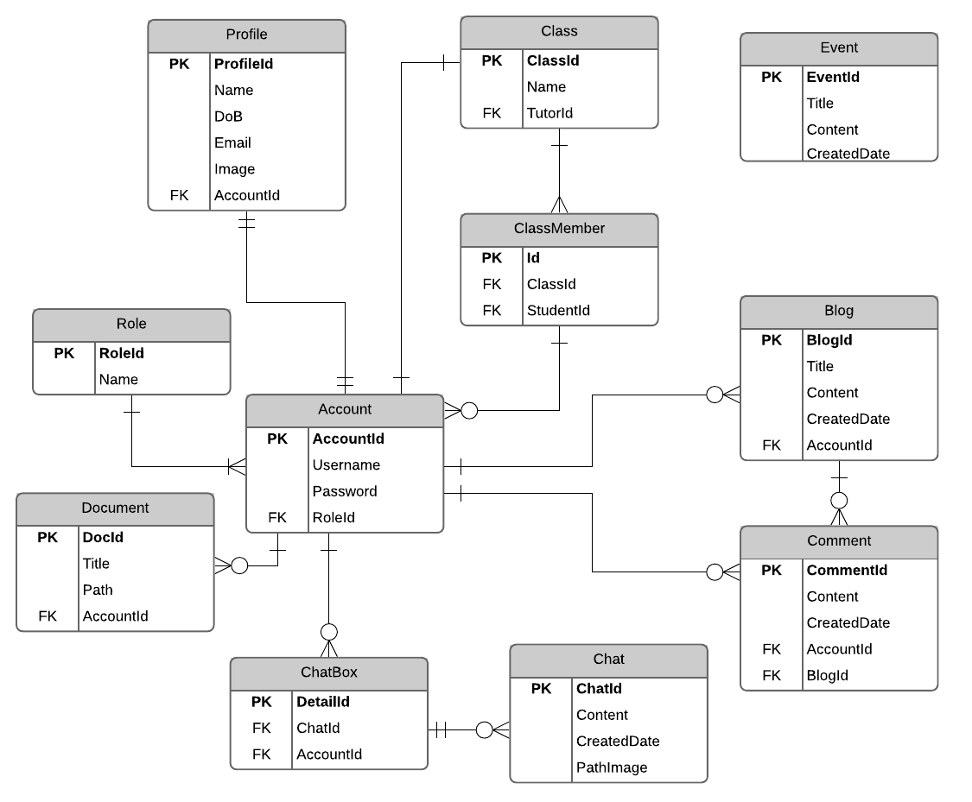

|  |  |  |
| --- | --- | --- |
| Table | Relationship | Description |
| Role | 1-many | Each account can have only one role.  A role can belong to many accounts |
| Account | Many-1 | An Account has a role is student belongs to a ClassMember.  Each ClassMember can have many Accounts have role student. |
| 1 - zero or many | An Account can have zero or many Blogs.  Each blog belongs to an Account. |
| 1 – zero or many | An Account can have zero or many Comments.  Each comment belongs to an Account. |
| Document | Zero or many-1 | An Account has a role is tutor can have zero or many Documents.  Each Document belongs to an Account. |
| ChatBox | Zero or many-1 | An Account can have zero or many ChatBox.  Each ChatBox belongs to an Account. |
| Chat | Zero or many - 1 | A ChatBox can have zero or many Chat. Each Chat belongs to a ChatBox. |
| Class | 1-1 | A Class can only have an Account has role is Tutor.  Each Account has role is Tutor can only belong to a class. |
| ClassMember | Many - 1 | A class can have many ClassMember.  Each ClassMember belongs to a class. |
| Profile | 1 - 1 | An Account only belongs to a profile.  A profile is also only belonged to an account. |
| Blog | 1-zero or many | A Blog can have zero or many Comments.  Each comment belongs to a Blog |
| Comment | Zero or many - 1 | An account can have zero or many comments.  Each comment belongs to an account. |
| Event |  |  |

* 1. **Use Case Diagram**

To support the analysis and development of the eTutoring system, we will use the Use case Diagram. Use case will help capture the functional requirements of the system. Each Use case will describe how external users interact with the system to achieve certain goals as required by the scenario.

* **Staff Use case**

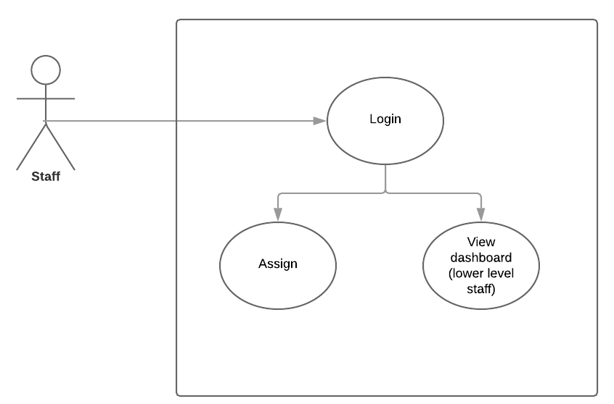

* **Student Use case**

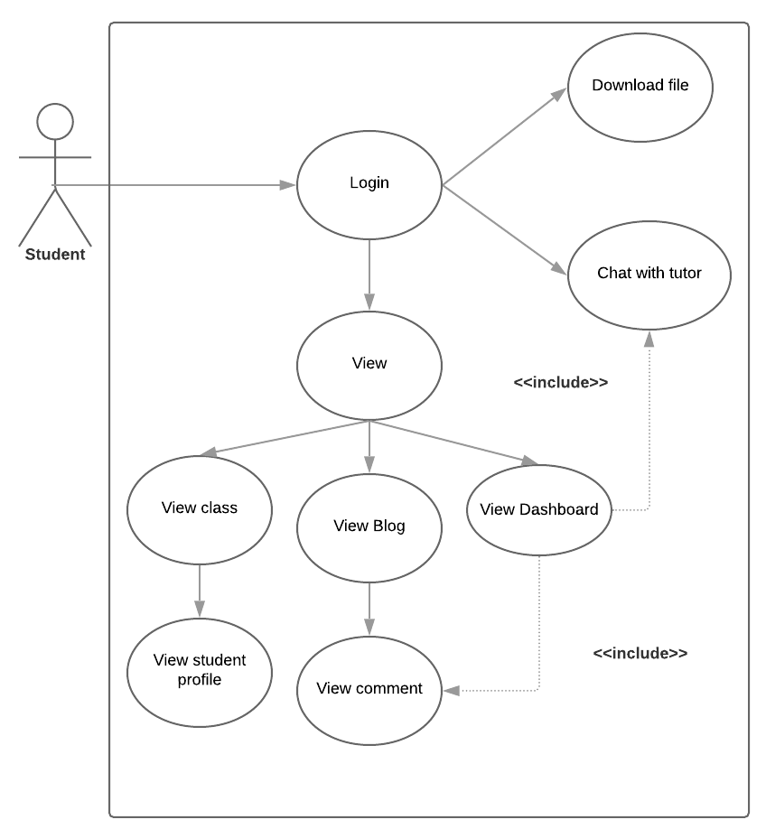

* **Tutor Use case**

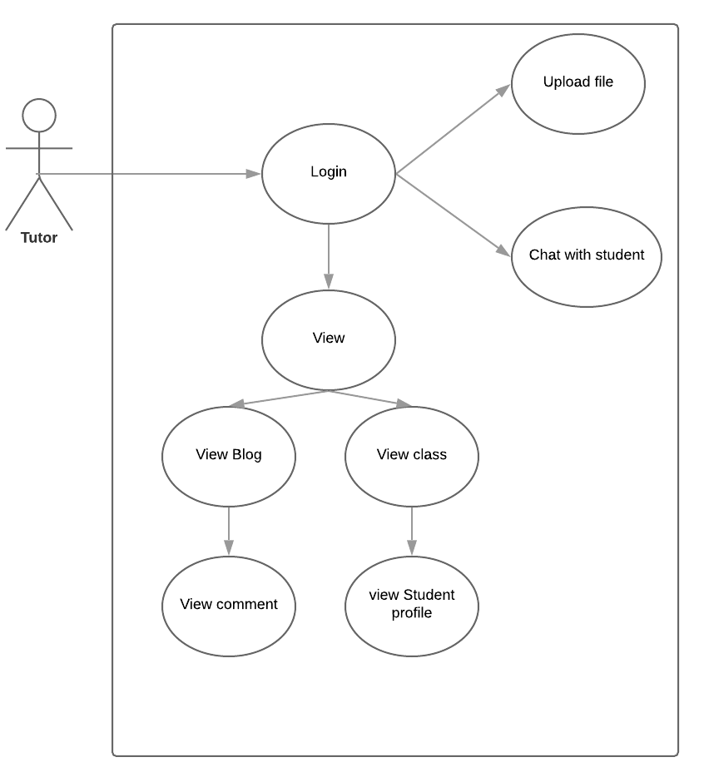

1. **Implement**
   1. **Sprint 1**
      1. **Sprint backlog**

|  |  |  |  |  |  |  |  |  |
| --- | --- | --- | --- | --- | --- | --- | --- | --- |
| User Stories | Tasks | Implementer | Estimate hours | Day 1 | Day 2 | Day 3 | Day 4 | Day 5 |
| As a user, I want to be able to login website. | Design Login Wireframe | N.M.Tam | 2 | 2 | 0 | 0 | 0 | 0 |
| Design Login Interface | V.T.T.Hieu | 5 | 3 | 2 | 0 | 0 | 0 |
| Design ERD | L.T.Dung | 5 | 3 | 0 | 2 | 0 | 0 |
| Code Database Model | L.T.Dung | 4 | 0 | 0 | 2 | 2 | 0 |
| Code Login function | T.N.Huy | 4 | 0 | 0 | 2 | 2 | 0 |
| Test Login Function | L.Tan.Nguyen | 1 | 0 | 0 | 0 | 0 | 1 |
|  | | | | | | | | |
| As a tutor, I want to see all of the necessary information of students who are taught by me. | Design Tutor manage page wireframe | N.M.Tam | 2 | 2 | 0 | 0 | 0 | 0 |
| Design Tutor manage page interface | V.T.T.Hieu | 3 | 3 | 0 | 0 | 0 | 0 |
| Design Function to list students information | T.N.Huy | 4 | 2 | 2 | 0 | 0 | 0 |
|  | | | | | | | | |
| As a staff, I want to allocate or reallocate personal tutors to students. | Design Allocate page wireframe | N.M.Tam | 2 | 1 | 1 | 0 | 0 | 0 |
| Design Allocate page Interface | V.T.T.Hieu | 4 | 0 | 2 | 2 | 0 | 0 |
| Code Allocate function | T.N.Huy | 8 | 2 | 3 | 1 | 2 | 0 |
| Test Allocate function | L.T.Nguyen | 1 | 0 | 0 |  | 1 | 0 |
|  |  | **Total** | 45 | 18 | 10 | 9 | 7 | 1 |

* + 1. **Burndown chart**
    2. **Sprint goal**
* As a user, I want to be able to login website.
* As a tutor, I want to see all of the necessary information of students who are taught by me
* As a staff, I want to allocate or reallocate personal tutors to students.
  + 1. **Retrospective**

|  |  |
| --- | --- |
| **Tasks did well** | **Tasks need improvement** |
| The wireframe design of sprint 1 is on time | Wireframe design is quite simple and not eye-catching |
| User interface design is exactly like wireframe | Complex ERD design and inaccurate relationships |
| Login function can save the information of the current user | Login function completed slower than planned |
| You must use the Login function to gain access to the system |  |
| ERD design is on time |  |
| The allocate and reallocate functions complete correctly at the scheduled time. |  |

* 1. **Sprint 2**
     1. **Sprint backlog**

|  |  |  |  |  |  |  |  |  |
| --- | --- | --- | --- | --- | --- | --- | --- | --- |
| User Stories | Tasks | Implementer | Estiamate hours | Day 1 | Day 2 | Day 3 | Day 4 | Day 5 |
| As a student (or personal tutor), I want to be notified via email when allocating or reallocating happens | Code email sending function | T.N.Huy | 8 | 2 | 2 | 2 | 2 | 0 |
| Test email sending function | L.T.Nguen | 1 | 0 | 0 | 0 | 1 | 0 |
| As a staff, I want to allocate a huge number of students (10 students at time) to the personal tutor. | Update allocate function | T.N.Huy | 5 | 3 | 2 | 0 | 0 | 0 |
| Test allocate function | L.T.Nguen | 1 | 0 | 1 | 0 | 0 | 0 |
| As a student (or personal tutor), I want to use this system to write blog, send message for each other, arrange as well as recording meetings, upload documents and comment on them. | Design blog page wireframe | N.M.Tam, V.T.T.Hieu | 4 | 3 | 1 | 0 | 0 | 0 |
| Design chat page wireframe | N.M.Tam, V.T.T.Hieu | 4 | 3 | 1 | 0 | 0 | 0 |
| Code Chat function | L.T.Dung | 10 | 6 | 2 | 2 | 0 | 0 |
| Code Blog function | T.N.Huy | 10 | 3 | 3 | 2 | 0 | 2 |
| Code comment function | T.N.Huy | 8 | 0 | 1 | 4 | 3 | 0 |
| Test Chat function | L.T.Nguen | 1 | 0 | 0 | 0 | 0 | 1 |
| Test blog function | L.T.Nguen | 1 | 0 | 0 | 0 | 0 | 1 |
| Test comment function | L.T.Nguen | 1 | 0 | 0 | 0 | 0 | 1 |
|  |  | **Total** | 54 | 20 | 13 | 10 | 6 | 5 |

* + 1. **Burndown chart**